Infographic Instructions

What is an infographic? Infographics use pictures, images, and colors along with content to communicate information.
In order to understand how an infographic works, let’s take a look at some examples.
This example is a set of infographics that show a story’s plot. Each one shows the ups and downs of the story with a black shape, the details of the story in blue symbols, and explanation in text at the bottom.

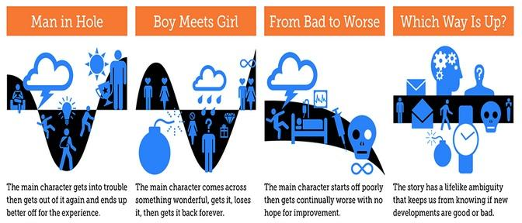
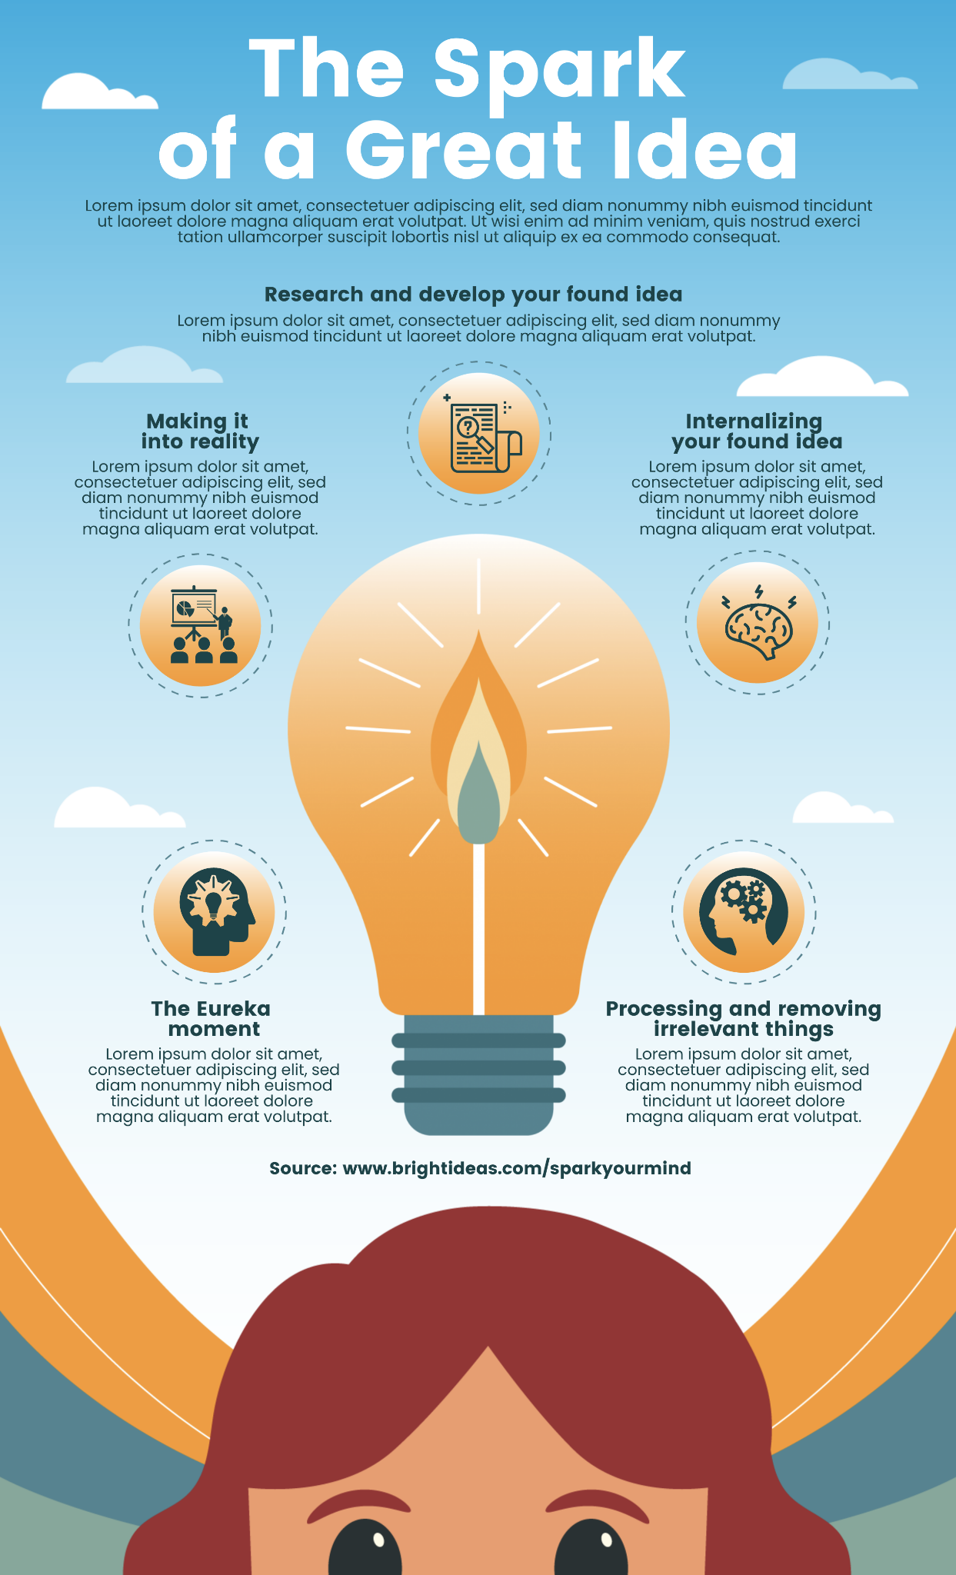

​​

This example illustrates how the brain creates an idea. There is the central graphic (a head indicating the brain and a light bulb indicating the idea). Then there are secondary graphics representing each task the brain completes in the process. Each secondary graphic has a short paragraph explaining that task.

Now that you are familiar with what infographics look like, you are going to make your own infographic about King Philip’s War.
- Look at your historical article annotation activity. You have already identified the most important pieces of information from the article. You will use these pieces of information to create your infographic. Your infographic will help viewers understand King Philip’s War.
  - Open your historical annotation activity.
  - Review each important piece of information you recorded.
  - Brainstorm a picture/shape/graphic that could represent or symbolize each piece of information.
  - Open your written explanation activity.
  - Review the two pieces of evidence you recorded.
  - Brainstorm a picture/shape/graphic that could represent or symbolize each piece of evidence.
  - Choose the best four sentences from your reviews, above, to use in your infographic.
  - Lastly, brainstorm a theme or central graphic that could tie your infographic together.

- Make a copy of this template to create your infographic, or access an online infographic making template (examples: https://infogram.com/ or https://piktochart.com/ ).

- Add to the 4 text boxes in the Google slide using the important pieces of information from your historical annotation activity and your evidence from the written explanation activity. Add graphics that visually represent your textboxes. Add a central graphic or theme.

